Chapter 2, Solution 25

V₀ = 5 x 10⁻³ x 10 x 10³ = 50V

Using current division,

I₂₀ 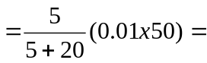 0.1 A

V₂₀ = 20 x 0.1 kV = 2 kV

p₂₀ = I₂₀ V₂₀ = 0.2 kW

